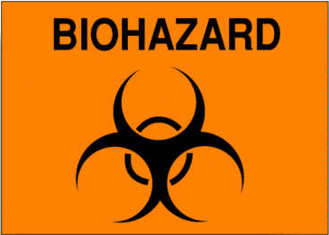CAUTION
AUTHORIZED PERSONNEL ONLY

ETIOLOGIC AGENT:

BIOSAFETY LEVEL:

PRINCIPAL INVESTIGATOR:

EMERGENCY NUMBER:

REQUIRED IMMUNIZATIONS:

PPE REQUIRED:

SPECIAL HAZARDS:

PROCEDURES FOR ENTERING / EXITING THE LAB:

OEHS EMERGENCY NUMBERS:
For emergency response during work hours:
For emergency response after work hours:

